Job No: {{job_number}}
Date: {{date}}

{{council_name}}

Dear Sir,

NEW DWELLING

Compliance with Building Code Clause B2 – Durability.

The purpose of this letter is to demonstrate how compliance with Clause B2 – Durability of the Building Code will be achieved for the above project. We can confirm that for specifically designed structural elements that are included within our design documentation:

Material | Means of Compliance | Notes
Reinforced concrete | B2/AS1 | Concrete cover to reinforcing has been selected in accordance with NZS3101, Part 1, Section 3.
Structural timber | B2/AS1 | Timber treatment has been selected in accordance with Table 1A of B2/AS1
Mild steel structure | Alternative Solution | Steel protection has been specified in accordance with the “Guide to the protection of structural steel against atmospheric corrosion by the use of protective coatings” AS/NZS 2312. We note this is on a first time to maintenance basis. Steel coating design is to be provide by the paint manufacturer.

We trust this provide the information that you are seeking.

Yours faithfully,
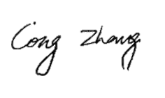
Kevin Zhang
Director | Senior Structural Engineer
BEng Msc CMEngNZ CPEng(NZ&UK) MIStructE

For and on behalf of
Engsolution ltd.

